Paolo Yshmael C. Trinidad

JavaScript Drill: Part II
Lab2.1 Variables and Data Types Objective
Declare and display variables of different data types.

Instructions

- Declare variables: name (string), age (number), isStudent (boolean), grades (array),
student (object).
- Print them and their types using console.log and typeof.

Code:

let name = "Juan"; let age = 20;
let isStudent = true;
let grades = [85, 90, 92];
let student = {firstName: "Juan", lastName: "Dela Cruz"};
console.log(name, typeof name); console.log(age, typeof age); console.log(isStudent, typeof isStudent); console.log(grades, typeof grades); console.log(student, typeof student);

Expected Output

Juan string
20 number
true boolean [85, 90, 92]
object {firstName: "Juan", lastName: "Dela Cruz"} object

Lab 2.3: Arithmetic & Type Conversion Objective
Perform arithmetic operations and demonstrate type conversion.

Instructions

- Ask the user for two numbers using prompt().
- Perform addition, subtraction, multiplication, and division.
- Display results in an alert.
- Show conversion of a string to a number and a number to boolean.

Code:

let num1 = Number(prompt("Enter first number:")); let num2 = Number(prompt("Enter second number:"));

let sum = num1 + num2; let diff = num1 - num2; let prod = num1 * num2; let div = num1 / num2;
alert(`Results:
Sum = ${sum}
Difference = ${diff} Product = ${prod}

Division = ${div}`);
let numString = "123";
let numValue = Number(numString); let boolValue = Boolean(0);

console.log("String:", numString, "Type:", typeof numString); console.log("Converted Number:", numValue, "Type:", typeof numValue);
console.log("Boolean Value of 0:", boolValue);

Expected Output

If the user enters 10 and 5:
Results:
Sum = 15
Difference = 5
Product = 50
Division = 2
Console:
String: 123 Type: string
Converted Number: 123 Type: number
Boolean Value of 0: false Type: boolean

Lab 2.4: Conditional Statements Objective
Use comparison and logical operators in conditionals.

Instructions

- Ask the user for their age.
- If 18 or older, display “You are an adult.” Otherwise, display “You are a minor.”
- Validate the input to ensure it’s numeric.

Code:

let ageInput = prompt("Enter your age:"); let ageNum = Number(ageInput);

if (!isNaN(ageNum) && ageNum >= 18) { alert("You are an adult.");
} else if (!isNaN(ageNum)) { alert("You are a minor.");
} else {
alert("Invalid input!");
}

Expected Output

- If the user enters 20:
You are an adult.
- If the user enters 15:
You are a minor.
- If the user enters a non-numeric value:
Invalid input!

Lab 2.5: Loops Objective
Practice for and while loops.

Instructions

- Use a for loop to display numbers 1–10 in the console.
- Ask the user for a number and compute its factorial using a while loop.

Code:

// For loop
for (let i = 1; i <= 10; i++) { console.log(i);
}

// Factorial using while loop
let n = Number(prompt("Enter a number to compute factorial:")); let fact = 1;
let i = 1;
while (i <= n) { fact *= i; i++;
}
console.log(`Factorial of ${n} = ${fact}`);

Expected Output

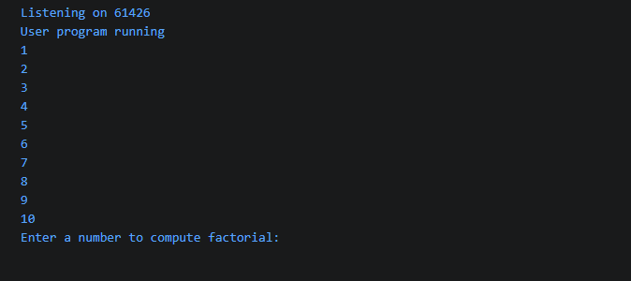

Lab 2.6: Arrays and Objects Objective
Manipulate arrays and objects.

Instructions

- Create an array of fruits with three elements and add another using .push().
- Remove the first fruit using .shift().
- Create an object student with properties name, age, and course.
- Print both the array and object to the console.

Code:

let fruits = ["apple", "banana", "mango"]; fruits.push("orange");
fruits.shift(); console.log(fruits);
let student = { name: "Maria", age: 21, course: "IT"
};
console.log(student);

Expected Output

- Console shows updated fruits array.
- Console shows student object.

